Milestone 6
Testing the Configuration

Objective
Test the configured UI Policy and Client Scripts to verify mandatory enforcement, successful save, reverse behavior, list-edit blocking, and form-based updates.

Activity 1 – Test Mandatory Enforcement

Steps
- Open Incident → Create New.
- Set Impact to High.
- Leave Assigned To empty.
- Click Submit.
- Verify that the Incident is not saved and an error message appears.
- Confirm the configured UI Policy and automatic Urgency behavior.

Expected Result
The Incident should not be saved because Assigned To is required when Impact is High.

Activity 2 – Test Successful Save

Steps
- Open the Incident form.
- Select a user in Assigned To.
- Click Submit.
- Verify that the Incident is saved successfully.
- Confirm Urgency auto-setting, read-only behavior, and State restrictions.

Expected Result
The Incident should save successfully when the required information is provided.

Activity 3 – Reverse Condition Test

Steps
- Open an Incident where Impact is High.
- Change Impact from High to Medium.
- Verify that Assigned To is no longer mandatory.
- Verify that Urgency becomes editable.
- Save the record.

Expected Result
The UI Policy reverse condition should restore the appropriate field behavior when Impact is no longer High.

Activity 4 – Test List Edit Blocking

Steps
- Navigate to Incident → All.
- Locate an Incident.
- Double-click the State field.
- Verify the alert message.
- Confirm that the State value remains unchanged.

Expected Result
Direct changes to State through list editing should be blocked.

Activity 5 – Test Form-Based Update

Steps
- Open the same Incident record.
- Change the State field on the Incident form.
- Click Update.
- Verify that the State change is saved successfully.
- Confirm that Assigned To and Urgency still follow the configured rules.

Expected Result
State changes made through the Incident form should be saved successfully.

Conclusion
The configuration demonstrates how UI Policies and Client Scripts work together to enforce dynamic field behavior, automate updates, and prevent incorrect data submission on Incident forms. The implementation uses onChange, onSubmit, and onCellEdit scripts alongside UI Policy actions to control Assigned To, Urgency, and State behavior according to Incident Impact and editing context.
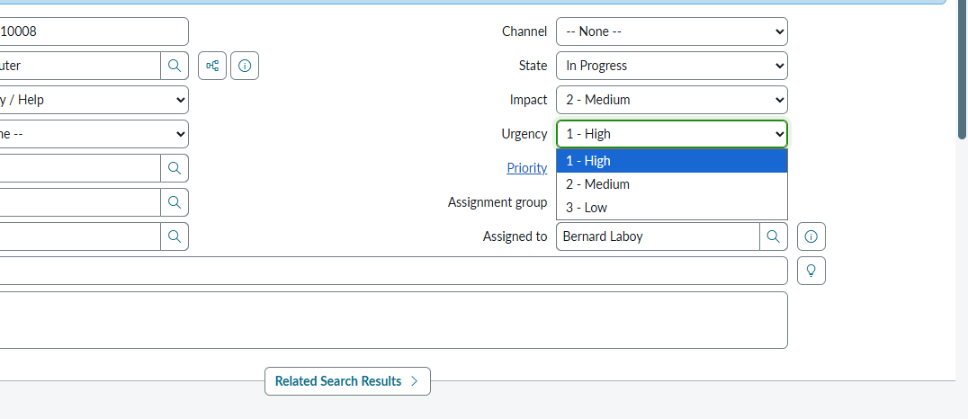
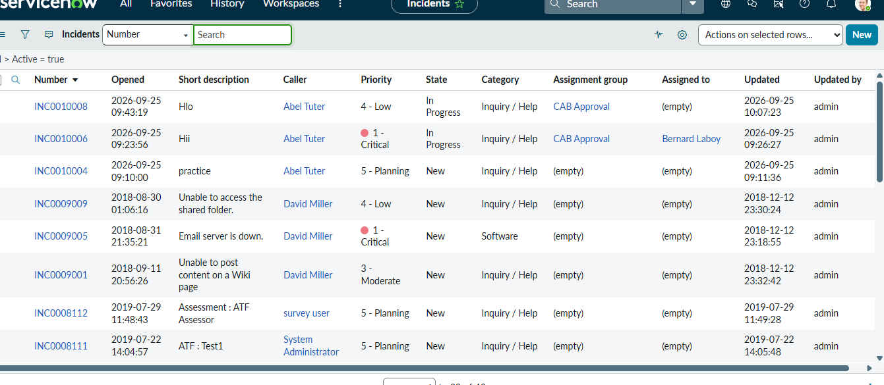
Use the nine project screenshots in the repository's screenshots folder and reference the appropriate image beside each test in the final documentation.

